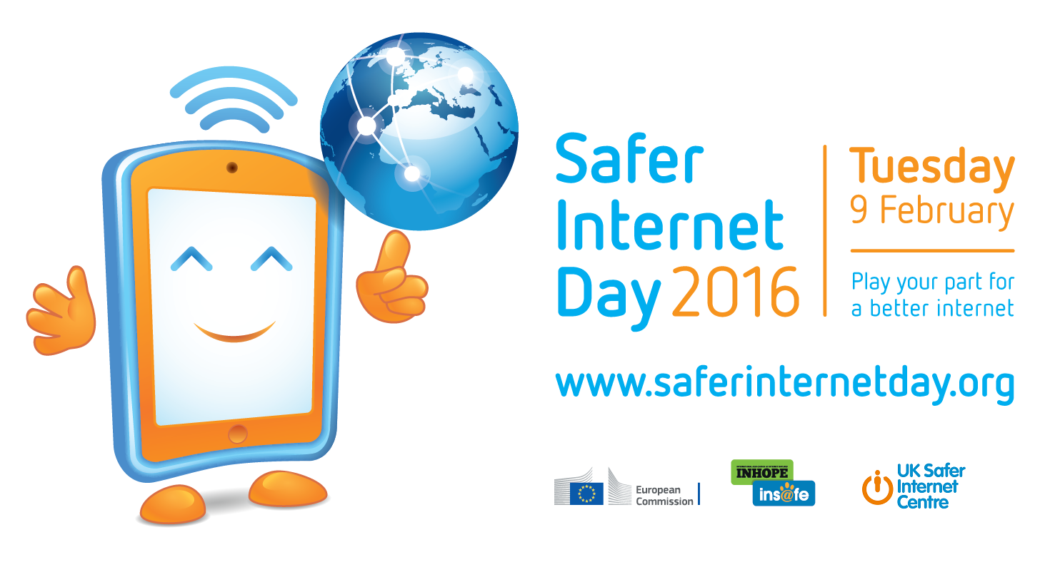

Key messages for the Safer Internet Day 2016 campaign

Safer Internet Day 2016 will be celebrated globally on Tuesday 9th February with the slogan ‘Play your part for a better internet’.

Coordinated in the UK by the UK Safer Internet Centre the celebration sees hundreds of organisations get involved to help promote the safe, responsible and positive use of digital technology for children and young people.

Globally, Safer Internet Day (SID) is organised by the joint Insafe/INHOPE network, with the support of the European Commission, each February to promote safer and more responsible use of online technology and mobile devices, especially among children and young people. Celebrated on the second day of the second week of the second month, each year on Safer Internet Day thousands of people join together to participate in events and activities to raise awareness of online safety issues, right across the globe.

The online safety landscape has evolved over recent years from a focus on creating a ‘safer’ internet to creating a ‘better’ internet. Whether we are children and young people, parents and carers, educators or social care workers, or indeed industry, decision makers or politicians, we all have a role to play.

In championing a better internet, the theme aims to encourage people to play their part in making the most of the positive opportunities offered online, while giving them the resilience, skills, knowledge and support they need to navigate any online risks they may come across.

There are ways in which we can all contribute:
- Children and young people can help to create a better internet by being kind and respectful to others online, by protecting their online reputations (and those of others), and by seeking out positive opportunities to create, engage and share online. They can help to respond to the negative by being ‘helpful bystanders’: supporting peers if they encounter issues online, taking a stand against cyberbullying, and reporting any inappropriate or illegal content they find. Above all, children and young people should be encouraged to take their stand as digital citizens of the future – participating in debates on the future of the internet, and making their voices heard.

- Parents and carers can help to create a better internet by maintaining an open and honest dialogue with their children about their online lives, by supporting them with their personal development online and helping them to deal with any concerns or issues, seeking out positive opportunities to engage with their children online, and helping their children to find and use good quality digital resources. They can help to respond to the negative by staying engaged with their child’s online activity (as appropriate to their age), by modelling positive online behaviours themselves, and by also reporting any inappropriate or illegal content they find.

- Educators and social care workers can help to create a better internet by equipping children and young people with the digital literacy skills they require for today’s world, and giving them opportunities to use – and create – positive content online. They can help to respond to the negative by supporting young people if they encounter problems online, and by giving them the resilience, confidence and skills that young people need to navigate the internet safely.

- Industry has a role to play by creating and promoting positive content and safe services online and by empowering users to respond to any issues by providing clear safety advice, a range of easy-to-use safety tools, and quick access to support if things do go wrong.

- Decision makers and politicians need to provide the culture in which all of the above can function and thrive – for example, by ensuring that there are opportunities in the curriculum for children to learn and teachers to teach about online safety, ensuring that parents and carers have access to appropriate information and sources of support, and that industry are encouraged to self regulate their content and services. They must also take the lead in governance and legislation, and ultimately ensure the safety and wellbeing of children and young people through effective child protection strategies for the online world.

We hope that you will join with us, and Safer Internet Day supporters across the globe, on Tuesday 9 February 2016 – and beyond – to play your part in helping to create a better internet!

Find out more about what is happening in the UK on Safer Internet Day at www.saferinternet.org.uk/safer-internet-day

Find out more about what is happening globally on Safer Internet Day at www.saferinternetday.org.

Join the conversation #SID2016

* Safer Internet Day would not be possible without the support of the European Commission. Currently the funding is provided by the Connecting Europe Facility programme (CEF). Find out more about the EC’s ‘European Strategy for a Better Internet for Children’ on the Digital Agenda website.

