Key information
For use in press releases, newsletters, websites, and more!
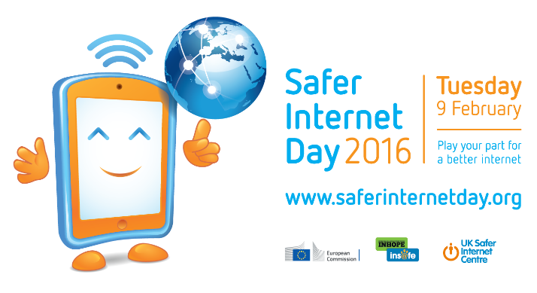

Safer Internet Day

Safer Internet Day 2016 will be celebrated globally on Tuesday 9th February with the slogan ‘Play your part for a better internet’.

Coordinated in the UK by the UK Safer Internet Centre the celebration sees hundreds of organisations get involved to help promote the safe, responsible and positive use of digital technology for children and young people.

The UK Safer Internet Centre – a partnership of three leading charities; Childnet, the South West Grid for Learning and the Internet Watch Foundation – provide resources for children, schools and families, and tools for getting involved at www.saferinternet.org.uk.

Globally, Safer Internet Day is celebrated in over a hundred countries, coordinated by the joint Insafe/INHOPE network, with the support of the European Commission, and national Safer Internet Centres across Europe.

The day offers the opportunity to highlight positive uses of technology and to explore the role we all play in helping to create a better and safer online community. It calls upon young people, parents, carers, teachers, social workers, law enforcement, companies, policymakers, and wider, to join together in helping to create a better internet. Get involved to play your part!

#SID2016

UK Safer Internet Centre
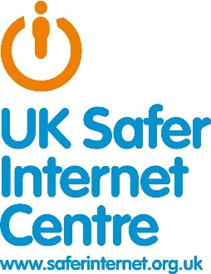
In addition to coordinating Safer Internet Day, the UK Safer Internet Centre delivers a wide range of activity to promote the safe and responsible use of technology:
- founded and operates an e-safety helpline for professionals working with children in the UK
- operates the UK’s hotline for reporting online criminal content
- develops new educational resources for children, parents and carers and teachers to meet emerging trends in the fast-changing online environment
- delivers education sessions for children, parents, carers, teachers and the wider children’s workforce
- shapes policy at school, industry and government level, both in the UK and internationally, and facilitates youth panels to give young people a voice on these issues.

